GPO Analysis
A network capture from the boot sequence of a domain-joined workstation has been provided. Analyze the traffic and extract the administrator’s password.
- Извлечение Groups.xml из SMB-трафика:
tshark -r gpo.pcap -Y "smb2.cmd == 8 || smb.cmd == 0x2e" -T fields -e data | xxd -r -p | strings | grep -i cpassword
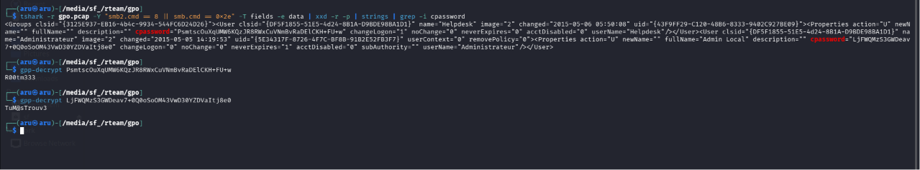
Расшифровка
Флаг: TuM@sTrouv3

